

Centre Name: ACE-HCMC-2-FPT (VN.033)

Address: 590 Cách Mạng Tháng 8 Street, District 3, Ho Chi Minh City, Viet Nam



ITM COLLEGE

MANAGEMENT

Design Document

|  |  |  |  |
| --- | --- | --- | --- |
| **Faculty:** | | **Mr. Tran Phuoc Sinh** |  |
| **Batch No:** | | **F2-10-1203-T0** |  |
| **Group No:** | | **02** |  |
| **Student** |  | **Full Name** | **Roll No.** |
|  | 1. | NGUYEN VU HUNG | STUDENT636555 |
|  | 2. | TRAN VAN HAI | STUDENT630717 |
|  | 3. | LE NGOC NHUT | STUDENT636217 |
|  | 4. | TRAN DUNG TRI | STUDENT682906 |

May 2013

# Table of Contents

Table of Contents 2

I. Acknowledgment 9

II. Problem Definition 10

1. Introduction 10

2. Existing Scenario 10

III. Requirement Specification 12

1. Customer Requirement Specification: 12

2. Functional Requirements Specification 13

2.1. Administrator 13

2.2. College Officer 13

2.3. Student 13

3. Hardware / Software Requirements 14

3.1. Hardware Requirements 14

3.2. Software Requirements 14

IV. Task sheet review 1 15

I. Architecture & Design of the Project 17

1. Presentation Tier: 18

2. Business Logic Tier: 18

3. Data Access Tier: 18

II. Algorithms - Data Flowchart: 19

1. Login process 19

2. Logout process 20

3. Online Admission 21

4. Student Registration 22

5. Insert process 23

6. Update process 24

7. Delete process 25

8. Search process 26

III. Data Flow Diagram 27

1. Context Level Diagram 28

2. Level 0 DFD 29

3. Level 1 DFD 31

3.1. Level 1 DFD – Administrator Manage Department 31

3.2. Level 1 DFD – Administrator Manage Faculty 31

3.3. Level 1 DFD – Staff Manage Course 32

3.4. Level 1 DFD – Staff Manage Time Table 32

3.5. Level 1 DFD – Online Admission 33

3.6. Level 1 DFD – Student Registration 33

3.7. Process Decomposition 34

IV. Use Case Diagram 35

1. Administrator Use Case 36

2. Staff Use Case 37

3. Student Use Case 38

4. Guest Use Case 38

V. Sequence Diagram 39

1. Login 39

2. Logout 41

3. Online Admission 42

4. Student Registration 44

5. Insert 46

6. Update 48

7. Delete 50

8. Search 52

VI. Entity–Relationship Design 54

1. Entity–Relationship Diagram 54

2. Entities and Properties 55

2.1. Accounts Entity & Properties 55

2.2. Department Entity & Properties 55

2.3. Facilities Entity & Properties 55

2.4. Faculty Entity & Properties 56

2.5. Courses Entity & Properties 56

2.6. OnlineAdmission Entity & Properties 57

2.7. StudentRegistration Entity & Properties 58

2.8. Assignments Entity & Properties 58

2.9. FeedBacks Entity & Properties 58

2.10. Branches Entity & Properties 59

2.11. CollegeContents Entity & Properties 60

VII. Task sheet review 2 61

I. Database Design 63

1. Database Relationship Diagram (DRD) 63

2. Database Structure 64

2.1. Table: Accounts 64

2.2. Table: Departments 64

2.3. Table: Faculty 64

2.4. Table: Courses 65

2.5. Table: OnlineAdmission 65

2.6. Table: StudentRegistration 66

2.7. Assignments Entity & Properties 66

2.8. FeedBacks Entity & Properties 66

2.9. Branches Entity & Properties 67

2.10. CollegeContents Entity & Properties 67

2.11. Facilities Entity & Properties 67

3. Database Constrains 68

3.1. Table: Accounts 68

3.2. Table: Departments 68

3.3. Table: Faculty 68

3.4. Table: Courses 68

3.5. Table: StudentRegistration 69

3.6. Table: Assignments 69

3.7. Table: FeedBacks 69

3.8. Table: Branches 69

3.9. Table: Facilities 70

3.10. Table: CollegeContents 70

II. GUI Designs – Front-End 71

1. Homepage 71

2. Departments 73

3. Department Detail 74

4. Facilities 75

5. Facility Detail 76

6. Faculty 77

7. Courses 78

8. Contact 79

9. Online Admission Form 80

10. Check Admission Status 82

11. Student Registration 83

III. GUI Design – Back-End 84

1. Login Form 84

2. Administrator Dashboard 85

3. Administrator – Departments 86

4. Administrator – Departments – Create New / Edit 87

5. Administrator – Departments – Delete 88

6. Administrator – Facilities 89

7. Administrator – Facilities – Form Add/Edit 90

8. Administrator – Facilities – Delete 91

9. Administrator – Faculty 92

10. Administrator – Faculty – Add/Edit Form 93

11. Administrator – Faculty – Delete 94

12. Administrator – Online Admission 95

13. Administrator – Online Admission – Update 96

14. Administrator – Accounts 98

15. Administrator – Account – Add/Edit Form 99

16. Administrator – Account - Delete 100

17. Administrator – Branches 101

18. Administrator – Branches – Add/Edit 102

19. Administrator – Branches – Delete 103

20. Change Password 104

21. Staff Dashboard 105

22. Staff – Courses 106

23. Staff – Course – Add/Edit 107

24. Staff – Student 109

25. Staff – College Content 110

26. Staff – College Content – Form 111

27. Staff – Assignment 112

28. Staff – Assignments – Add/Edit 113

IV. Sitemap 114

1. Front-End Sitemap 114

2. Back-End Sitemap 115

V. Task sheet review 3 116



**Mr. Tran Phuoc Sinh**

Mr Nguyen Vu Hung

Mr Le Ngoc Nhut

Mr Tran Dung Tri

Mr Tran Van Hai



**This is to certify that**

**have successfully designed and**

**developed **

**Submitted by:**

**Date of Issue: ________**

**Authorized Signature: ___________**



**REVIEW I**

**ITM College Management**

14/05/2013

**REVIEW I**

# Acknowledgment

We would like to acknowledge all those who have given support and help us make the project a success.

We wish to express our deep gratitude to all teachers who have been devoting their lives to teach us how to stand-alone and walk ahead.

We are grateful to our families who take care and encourage us even though we are successful or failed, also to our friends who are always care of us. They never leave us alone and always look forward to us when we are on any road of the life.

We are much thankful to the entire staff and chairpersons at the Head Office of Aptech Worldwide, Aptech – Vietnam, and FPT – Aptech Center who have been organizing and looking after our studying course.

There are no words to show our appreciation for teachers of FPT Aptech Centre who have been organizing and looking after us during our studying course to finish this project. Our special thanks not only Mr Tran Phuoc Sinh who works day by day to teach and guide us in our travel to discover the wonder of Java Programming Language but also mentors in e-Project Team at the Head Office who instruct and help us.

Finally, we would like to offer many thanks to all our schoolfellows for their valuable suggestions.

We would like to thank sincerely!

Group 2 – FPT Aptech.

# Problem Definition

## Introduction

As of today world all the manual paper work like accounting, maintaining records are computerized. Even the college and school admission, result declaration is performed online today. Due to which all the school and colleges felt the need of making the website of their organization. The main purpose of making website is to attract the masses and advertisement of the school, colleges, and their achievements to the people leaving in any area (near or remote). The ITM College wants the website of the college to be developed and they have approached you for the same.

## Existing Scenario

**HOME PAGE**: Here there should be an introduction of the college with hyperlink at the top (for navigation) and various sections to highlight the important features of the college. There should be separate section for the Admin Login (where the details of website can be modified and updated).

**COURSES**: Here the details of all the courses must be stated which are available in the college.

**ADMISSION**: Here there will admission form for the students. All the admission form related to the particular subject must be there. Students can download the form or can also fill the form online and submit. Once the online form is submitted, then the student will get a unique registration number and this number must be used to check the admission status. If the student status is accepted then they can proceed the online submission by clicking proceed button or link and complete the further details like selection of subjects.

**DEPARTMENTS**: Here the details of the entire department must be added (like chemistry, French, Economics, Psychology, Geology and Mathematics).

**FACULTY**: Here it should state the details of the entire faculty (should be categorized according to their departments).

**FACILITIES**: Like what all Facilities are provided in the college such as college canteen, hostel, placement center, gymkhana, college library, administrator office)

**STUDENT REGISTRATION**: here the student can register themselves with the help of their ID (unique) so that they can get the updates of their colleges, assignments, exam timetable. If the same student tries to register again with the same ID then an error message must be thrown.

**CONTACT US**: It should state the contact details of the college (must cover all the branches).

**FEEDBACK FORM**: Here the feedback is taken from the end user.

**ADMIN LOGIN**: There should be separate section for login. The admin person will be able to update the data of the website.

A sample format of link is shown below:



# Requirement Specification

## Customer Requirement Specification:

The College had provided all the content details they want to add in the website. The details of the information and what link the Home page must contain? Name of the links required in the website for navigation. There should be section in the Home Page for Upcoming events in the college, Achievements, New course, Merit list. The Link like HOME, COURSES, STUDENT REGISTRATION, DEPARTMENTS, FACULTY, FACILITIES, ONLINE ADMISSION, CONTACT US, FEEDBACK, ADMIN LOGIN.

**Admission Procedure**

* The Admin will have the responsibilities of checking which student is eligible for the admission.
* When an Online admission form is filling by the student they will provide all the details of the previous education. In the first level of form filling the student is supposed to provide personal details like:
  + Name
  + Father Name
  + Mother Name
  + Date of Birth( as per the certificate)
  + Gender
  + Residential Address
  + Permanent Address
  + Admission for ( selecting a stream, field)
  + In tabular format ( details of previous exam)
    - University
    - Enrolment number
    - Center
    - Stream
    - Field
    - Marks secured
    - Out of
    - Class Obtained
  + Sports details (if any)
  + Submit ( for submitting the details)

Once the candidate click on the submit button a Unique number must be provided to them.

* + With the help of the Unique ID they can check the status of the admission like whether waiting, accepted.
* Once the status is confirmed, they can provide further details like specialized subject, optional subject and finally can print the form for seeking admission in the college.

## Functional Requirements Specification

### Administrator

Administrator will have ability of managing (include create new / edit / delete):

* Departments
* Faculty
* Facilities
* Courses
* Contact and Feedback information
* College’s Officers
* Online Admission

### College Officer

College Officer will have ability of managing (include create new / edit / delete):

* Student registration
* Exam time table
* Assignments
* Merit list
* College’s News
* College’s Upcoming Events

### Student

Students will have ability of viewing The College information:

* Upcoming events in the college
* Achievements
* New course
* Merit list
* Assignments
* Exam time table

## Hardware / Software Requirements

### Hardware Requirements

|  |  |
| --- | --- |
| **Component** | **Requirement** |
| Server | Processor type:  Pentium III-compatible processor or faster  Processor speed:  Recommended: 2.0 GHz or faster |
| OS | Microsoft Windows Server 2003 or higher |
| Memory (RAM) | RAM:  Minimum: 512 MB  Recommended: 2.048 GB or more  Maximum: Operating system maximum |
| Hard Drive | Free space:  Minimum: 50 MB  Recommended: 50 GB or more  Maximum: Operating system maximum |

### Software Requirements

|  |  |
| --- | --- |
| **Component** | **Requirement** |
| Microsoft .NET Framework | Version 4.0 |
| Microsoft Visual Studio | Microsoft Visual Studio 2010 |
| RDBMS | Microsoft SQL Server 2008 |
| Design Tool | Adobe Photoshop CS3 |
| Editor | Adobe Dreamweaver CS3 |
| Source Version Control | TortoiseSVN 1.7 |

# Task sheet review 1

|  |  |  |  |  |  |
| --- | --- | --- | --- | --- | --- |
| Project Ref. No: 2 | Project Title:  ITM College Management | Date of Preparation of Activity Plan | | | |
| No. | Task | Actual Start Date | Actual Days | Team Member Names | Status |
| 01 | Acknowledgment | April 26, 2013 | 2 | All Members | Completed |
| 02 | Problem Definition | All Members | Completed |
| 03 | Customer Requirement | All Members | Completed |
| 04 | Function Requirement | All Members | Completed |
| 05 | Hardware/Software | All Members | Completed |
| 06 | Task sheet | All Members | Completed |

|  |  |  |
| --- | --- | --- |
|  | Prepare By: Group | Approved By: Faculty |
| Date: Apr 26, 2013 | Team Leader  Nguyen Vu Hung | Tran Phuoc Sinh |

**REVIEW II**

# Architecture & Design of the Project



**Three-Tier Architecture of the Project**

## Presentation Tier:

Is the tier in which the users interact with an application. Presentation Tier contents Shared UI code, Code Behind and Designers used to represent information to user.

Technology: ASP.NET, DHTML, CSS, JavaScript, Ajax

## Business Logic Tier:

Is mainly working as the bridge between Data Tier and Presentation Tier. All the Data passes through the Business Tier before passing to the Presentation Tier.

Technology: OOP, ASP.NET

## Data Access Tier:

Is basically the server which stores all the application’s data. Data tier contents Database Tables, Database Views and other means of storing Application Data.

Technology: SQL Server, LINQ, ADO.NET

# Algorithms - Data Flowchart:

Symbol generates:



## Login process



## Logout process



## Online Admission



## Student Registration



## Insert process



## Update process



## Delete process



## Search process



# Data Flow Diagram

**Define**: Data Flows Diagram (DFD) describes the information flow in the system. The next step of system analysis is to consider in detail the information necessary for the implementation for functions discussed above and the one necessary for the improvement of the functions. Modelling tool frequently used for this purpose is DFD. DFD will support 4 main activities:

**Analysis**: DFD is used to determine requirement of users.

**Design**: DFD is used to map out plan and illustrate solution to analysis and users while designing a new system.

**Communication**: one of the strength of DFD is its simplicity and ease to understand to analysts and users;

**Document**: DFD is used to provide special description of requirement and system design. DFD provide an overview of key functional components of the system but it does not provide any detail on these components. We have to use other tools like database dictionary, process specification to get an idea of which information will be exchanged and how.

**The main components of Context Diagram:**

|  |  |  |
| --- | --- | --- |
|  | External | **The process**: Shows the common function of system  **The external factors**: External factors can be a person, a group of persons or an organization that are sources of information for the systems and are where system products are transferred to.  **The data flow**: Describe the movement of information from one part of the system to another.  **The data store**: The Data Store is used to model a collection of data packets at rest. A store is represented graphically by two parallel lines. The name of a Data Store that identifies the store is the plural of the name of the packets that are carried by flows into and out of the Data Store |
|  | The process |
|  | Data flow |
|  | Data store |

## Context Level Diagram



## Level 0 DFD





## Level 1 DFD

### Level 1 DFD – Administrator Manage Department



### Level 1 DFD – Administrator Manage Faculty



### Level 1 DFD – Staff Manage Course



### Level 1 DFD – Staff Manage Time Table



### Level 1 DFD – Online Admission



### Level 1 DFD – Student Registration



### Process Decomposition



# Use Case Diagram



## Administrator Use Case



## Staff Use Case



## Student Use Case



## Guest Use Case



# Sequence Diagram

## Login



|  |  |  |
| --- | --- | --- |
| **Use Case Name** | **Login** | |
| **Author** | Nguyen Vu Hung | |
| **Actors** | Administrator, Staff, Student | |
| **Description** | Actors use this use case to login to system | |
| **Requirements** |  | |
| **Pre-Conditions** |  | |
| **Post-Condition** |  | |
| **Basic Flow** | **Actors action**  1. Actors click on “Login “ button  3. Actors enter username and password into form.  4. Actors click “Login”  button  [**alternative**] | **System Response**  2. The system display ”Login” page the following control:  - “Username” text field  - “Password” text field  - “Login” button  - “Cancel” button  5. The system validate Username and Password  6. The system log Actors into system. |
| **Alternative Flow** | **Actors action**  [**alternative**] Actors click Cancel button | **System Response**  System return to Homepage |
| **Exceptions** | **Actors action**  [exception1] Actors provide invalid Username and Password | **System Response**  1. System display message: “The username or password provided are incorrect” |

## Logout



|  |  |  |
| --- | --- | --- |
| **Use Case Name** | **Logout** | |
| **Author** | Nguyen Vu Hung | |
| **Actors** | Administrator, Staff, Student | |
| **Description** | Actors use this use case to login to system | |
| **Requirements** |  | |
| **Pre-Conditions** | Already login into the System | |
| **Post-Condition** |  | |
| **Basic Flow** | **Actors action**  1. Actors click on “Logout “ button  3. Actors click “OK” button  [**alternative**] | **System Response**  2. System display message: “Do you want to logout?”  5. System logout Actors. |
| **Alternative Flow** | **Actors action**  [**alternative**] Actors click Cancel button | **System Response**  System return to previous page |
| **Exceptions** |  |  |

## Online Admission



|  |  |  |
| --- | --- | --- |
| Use Case Name | Online Admission | |
| Author | Tran Van Hai | |
| Actors | Admin | |
| Description | Actors use display Online Admission | |
| Requirements |  | |
| Pre-Conditions |  | |
| Post-Condition |  | |
| Basic Flow | Actors action  1. Actors click on “Online Admission “ button  3. Actors click “Submit”  button  [alternative] | System Response  2. The system display ” Online Admission” page the following with input personal details and details of previous exam  4. The system validate  [exception1  5. System save database |
| Alternative Flow | Actors action  [alternative] Actors click Cancel button | System Response  System return to Homepage |
| Exceptions | Actors action  [exception1] Actors provide invalid Online Admission | System Response  1. System display message: “error message” |

## Student Registration



|  |  |  |
| --- | --- | --- |
| **Use Case Name** | **Student Registration** | |
| **Author** | Le Ngoc Nhut | |
| **Actors** | Student | |
| **Description** |  | |
| **Requirements** |  | |
| **Pre-Conditions** | Actors has UNIQUEID | |
| **Post-Condition** |  | |
| **Basic Flow** | **Actors action**  1. Actors click on “Student Registration “ button  3. Actors click “Submit”  button  [alternative] | **System Response**  2. System display Student Registration page the following input specialized subject and input optional subject  4. Validate form [exception1]  5. System save database |
| **Alternative Flow** | **Actors action**  [alternative] Actors click Cancel button | **System Response**  System return to previous page |
| **Exceptions** | **Actors action**  [exception1] Actors provide invalid Student Registration | **System Response**  1. System display message: “error message” |

## Insert



|  |  |  |
| --- | --- | --- |
| **Use Case Name** | **Insert** | |
| **Author** | Tran Dung Tri | |
| **Actors** | Administrator, Staff | |
| **Description** | Actors use this use case to insert new information into system | |
| **Requirements** |  | |
| **Pre-Conditions** | Already logged in to the System as Administrator or Staff | |
| **Post-Condition** | Success: New information is saved into system database  Fail: Refill information | |
| **Basic Flow** | **Actors action**  1. Actors click on “Insert” button  3. Actors enter new information into required fields.  4. Actors click “Submit”  button  [**alternative**1] | **System Response**  2. System displays ”Insert” page  5. System validates new information  [**exception1**]  6. System saves new information into Database. |
| **Alternative Flow** | **Actors action**  [**alternative1**] Actors click “Cancel” button | **System Response**  System returns to previous page |
| **Exceptions** | **Actors action**  [**exception1**] Actors provide invalid information | **System Response**  1. System displays error message |

## Update



|  |  |  |
| --- | --- | --- |
| **Use Case Name** | **Update** | |
| **Author** | Tran Dung Tri | |
| **Actors** | Administrator, Staff | |
| **Description** | Actors use this use case to update new information into system | |
| **Requirements** |  | |
| **Pre-Conditions** | Already logged in to the system | |
| **Post-Condition** | Success: Selected information is updated into system database  Fail: Refill information | |
| **Basic Flow** | **Actors action**  1. Actors click on “Update” button  3. Actors update new information into required fields.  4. Actors click “Update”  button  [**alternative**] | **System Response**  2. System displays ”Update” page  5. System validates information  [**exception1**]  6. System updates new information into Database. |
| **Alternative Flow** | **Actors action**  [**alternative**] Actors click Cancel button | **System Response**  System returns to previous page |
| **Exceptions** | **Actors action**  [**exception1**] Actors provide invalid information | **System Response**  1. System displays error message |

## Delete



|  |  |  |
| --- | --- | --- |
| **Use Case Name** | **Delete** | |
| **Author** | Tran Dung Tri | |
| **Actors** | Administrator, Staff | |
| **Description** | Actors use this use case to delete information from system | |
| **Requirements** |  | |
| **Pre-Conditions** | Already logged in to the system | |
| **Post-Condition** | Success: Selected information is deleted from system database  Fail: Refill information | |
| **Basic Flow** | **Actors action**  1. Actors click on “Delete” button  4. Actors click “Yes” button  [**alternative**] | **System Response**  2. System displays “Delete Confirm” page  5. The system deletes the selected information  [**exception1**] |
| **Alternative Flow** | **Actors action**  [**alternative**] Actors click Cancel button | **System Response**  System returns to previous page |
| **Exceptions** | **Actors action**  [**exception1**] Actors provide invalid information | **System Response**  1. System displays error message |

## Search



|  |  |  |
| --- | --- | --- |
| **Use Case Name** | **Search** | |
| **Author** | Tran Dung Tri | |
| **Actors** | Administrator, Staff, Student | |
| **Description** | Actors use this use case to information into system | |
| **Requirements** |  | |
| **Pre-Conditions** | Already logged in to the system | |
| **Post-Condition** | Success: Found information is displayed on the “Display” page  Fail: Refill information | |
| **Basic Flow** | **Actors action**  1. Actors input search keyword into Keyword Text Field  2. Actors click on “Search“ button | **System Response**  3. System validate keywords  [exception1]  4. System display ”Search Result” page |
| **Alternative Flow** |  |  |
| **Exceptions** | **Actors action**  [exception1] Actors provide invalid keywords | **System Response**  1. System display error message |

# Entity–Relationship Design

## Entity–Relationship Diagram



## Entities and Properties

### Accounts Entity & Properties



### Department Entity & Properties



### Facilities Entity & Properties



### Faculty Entity & Properties



### Courses Entity & Properties



### OnlineAdmission Entity & Properties



### StudentRegistration Entity & Properties



### Assignments Entity & Properties



### FeedBacks Entity & Properties



### Branches Entity & Properties



### CollegeContents Entity & Properties



# Task sheet review 2

|  |  |  |  |  |  |
| --- | --- | --- | --- | --- | --- |
| Project Ref. No: 2 | Project Title:  ITM College Management | Date of Preparation of Activity Plan | | | |
| No. | Task | Actual Start Date | Actual Days | Team Member Name | Status |
| 01 | Architecture & Design of the Project | May 04, 2013 | 6 | Nguyen Vu Hung | Completed |
| 02 | Algorithms - Data Flowchart | Nguyen Vu Hung | Completed |
| 03 | Data Flow Diagram | Nguyen Vu Hung | Completed |
| 04 | Use Case Diagram | Le Ngoc Nhut | Completed |
| 05 | Sequence Diagram | Tran Dung Tri | Completed |
| 06 | ERD | Tran Van Hai | Completed |

|  |  |  |
| --- | --- | --- |
|  | Prepare By: Group | Approved By: Faculty |
| Date: May 04, 2013 | Team Leader  Nguyen Vu Hung | Tran Phuoc Sinh |

**REVIEW III**

# Database Design

## Database Relationship Diagram (DRD)



## Database Structure

### Table: Accounts

|  |  |  |  |  |  |  |
| --- | --- | --- | --- | --- | --- | --- |
| **Field Name** | **Data Type** | **Null** | **Default** | **Key** | **Field-Ref** | **Description** |
| accountID | INT | No | IDENTITY(1,1) | PK |  |  |
| username | VARCHAR(32) | No |  |  |  |  |
| password | VARCHAR(32) | No |  |  |  |  |
| role | VARCHAR(10) | No |  |  |  | Role for system:  1:admin  2:staff |

### Table: Departments

|  |  |  |  |  |  |  |
| --- | --- | --- | --- | --- | --- | --- |
| **Field Name** | **Data Type** | **Null** | **Default** | **Key** | **Field-Ref** | **Description** |
| departmentID | INT | No | IDENTITY(1,1) | PK |  |  |
| departmentName | VARCHAR(250) | No |  |  |  |  |
| departmentDescription | VARCHAR(1000) | No |  |  |  |  |
| departmentImage | VARCHAR (250) | No |  |  |  |  |
| departmentOrder | INT | No | 0 |  |  |  |
| disable | BIT | No | 0 |  |  |  |

### Table: Faculty

|  |  |  |  |  |  |  |
| --- | --- | --- | --- | --- | --- | --- |
| **Field Name** | **Data Type** | **Null** | **Default** | **Key** | **Field-Ref** | **Description** |
| facultyID | INT | No | IDENTITY(1,1) | PK |  |  |
| facultyName | VARCHAR(250) | No |  |  |  |  |
| facultyDescription | VARCHAR(1000) | No |  |  |  |  |
| facultyOrder | INT | No | 0 |  |  |  |
| facultyImage | VARCHAR(250) | No |  |  |  |  |
| departmentID | INT | No |  | FK | Departments.departmentID |  |
| disable | BIT | No | 0 |  |  |  |

### Table: Courses

|  |  |  |  |  |  |  |
| --- | --- | --- | --- | --- | --- | --- |
| **Field Name** | **Data Type** | **Null** | **Default** | **Key** | **Field-Ref** | **Description** |
| courseID | INT | No | IDENTITY(1,1) | PK |  |  |
| courseName | VARCHAR(250) | No |  |  |  |  |
| courseDescription | VARCHAR(1000) | No |  |  |  |  |
| departmentID | INT | No |  | FK | Departments.departmentID |  |
| facultyID | INT | No |  | FK | Faculty.facultyID |  |
| startDate | VARCHAR(50) | No |  |  |  |  |
| endDate | VARCHAR(50) | No |  |  |  |  |
| examDate | VARCHAR(50) | No |  |  |  |  |
| disabled | INT | No | 0 |  |  |  |

### Table: OnlineAdmission

|  |  |  |  |  |  |  |
| --- | --- | --- | --- | --- | --- | --- |
| **Field Name** | **Data Type** | **Null** | **Default** | **Key** | **Field-Ref** | **Description** |
| admissionID | INT | No | IDENTITY(1,1) | PK |  |  |
| Name | VARCHAR(250) | No |  |  |  |  |
| FatherName | VARCHAR(250) | No |  |  |  |  |
| MortherName | VARCHAR(250) | No |  |  |  |  |
| Birthday | VARCHAR(20) | No |  |  |  |  |
| Gender | BIT | No | 0 |  |  |  |
| ResidentialAddress | VARCHAR(250) | No |  |  |  |  |
| PermanentAddress | VARCHAR(250) | No |  |  |  |  |
| prevSportsDetails | VARCHAR(250) | No |  |  |  |  |
| prevUniversity | VARCHAR(250) | No |  |  |  |  |
| prevEnrolNumber | VARCHAR(250) | No |  |  |  |  |
| prevCenter | VARCHAR(250) | No |  |  |  |  |
| prevStream | VARCHAR(250) | No |  |  |  |  |
| prevField | VARCHAR(250) | No |  |  |  |  |
| prevMarks | VARCHAR(250) | No |  |  |  |  |
| prevOutOf | VARCHAR(250) | No |  |  |  |  |
| prevClass | VARCHAR(250) | No |  |  |  |  |
| status | BIT | No | 0 |  |  |  |

### Table: StudentRegistration

|  |  |  |  |  |  |  |
| --- | --- | --- | --- | --- | --- | --- |
| **Field Name** | **Data Type** | **Null** | **Default** | **Key** | **Field-Ref** | **Description** |
| registrationID | INT | No | IDENTITY(1,1) | PK |  |  |
| specializedSubject | INT | No |  | FK |  |  |
| optionalSubject | INT | No |  | FK |  |  |
| courseID | INT | No |  | FK | Coursrs.courseID |  |
| admissionID | INT | No |  | FK | OnlineAdmission. admissionID |  |
| Password | VARCHAR(30) | No | 0 |  |  |  |
| enrollNumber | INT | No |  |  |  |  |

### Assignments Entity & Properties

|  |  |  |  |  |  |  |
| --- | --- | --- | --- | --- | --- | --- |
| **Field Name** | **Data Type** | **Null** | **Default** | **Key** | **Field-Ref** | **Description** |
| assignmentID | INT | No | IDENTITY(1,1) | PK |  |  |
| assignmentName | VARCHAR(250) | No |  |  |  |  |
| assignmentDescription | VARCHAR(1000) | No |  |  |  |  |
| courseID | INT | No |  | FK | Courses.courseID |  |

### FeedBacks Entity & Properties

|  |  |  |  |  |  |  |
| --- | --- | --- | --- | --- | --- | --- |
| **Field Name** | **Data Type** | **Null** | **Default** | **Key** | **Field-Ref** | **Description** |
| feedbackID | INT | No | IDENTITY(1,1) | PK |  |  |
| feedbackContent | VARCHAR(1000) | No |  |  |  |  |
| courseID | INT | No |  | FK | Courses.courseID |  |

### Branches Entity & Properties

|  |  |  |  |  |  |  |
| --- | --- | --- | --- | --- | --- | --- |
| **Field Name** | **Data Type** | **Null** | **Default** | **Key** | **Field-Ref** | **Description** |
| brancheID | INT | No | IDENTITY(1,1) | PK |  |  |
| brancheName | VARCHAR(50) | No |  |  |  |  |
| brancheAddress | VARCHAR(250) | No |  |  |  |  |
| brancheEmail | VARCHAR(150) | No |  |  |  |  |
| branchePhone | VARCHAR(30) | No |  |  |  |  |
| brancheFax | VARCHAR(30) | No |  |  |  |  |
| Description | VARCHAR(1000) |  |  |  |  |  |

### CollegeContents Entity & Properties

|  |  |  |  |  |  |  |
| --- | --- | --- | --- | --- | --- | --- |
| **Field Name** | **Data Type** | **Null** | **Default** | **Key** | **Field-Ref** | **Description** |
| contentID | INT | No | IDENTITY(1,1) | PK |  |  |
| contentTitle | VARCHAR(1000) | No |  |  |  |  |
| contentImage | VARCHAR(250) | No |  |  |  |  |
| contentText | VARCHAR(1000) | No |  |  |  |  |
| contentCategory | VARCHAR(250) | No |  |  |  |  |

### Facilities Entity & Properties

|  |  |  |  |  |  |  |
| --- | --- | --- | --- | --- | --- | --- |
| **Field Name** | **Data Type** | **Null** | **Default** | **Key** | **Field-Ref** | **Description** |
| facilitieID | INT | No | IDENTITY(1,1) | PK |  |  |
| facilitieName | VARCHAR(1000) | No |  |  |  |  |
| facilitieImage | VARCHAR(250) | No |  |  |  |  |
| facilitieDescription | VARCHAR(1000) | No |  |  |  |  |

## Database Constrains

### Table: Accounts

Constraint:

* UNIQUE: username must be unique

|  |  |  |  |
| --- | --- | --- | --- |
| Name | Add | Delete | Update |
| Accounts | +  (username) | - | +  (username) |

### Table: Departments

Constraint:

* UNIQUE: departmentName must be unique

|  |  |  |  |
| --- | --- | --- | --- |
| Name | Add | Delete | Update |
| Departments | +  (departmentName) | - | +  (departmentName) |

### Table: Faculty

Constraint:

* UNIQUE: facultyName must be unique
* FOREIGN KEY: DepartmentID must exist

|  |  |  |  |
| --- | --- | --- | --- |
| Name | Add | Delete | Update |
| Faculty | +  (facultyName)  Departments.departmentID must exist | - | +  (facultyName)  Departments.departmentID must exist |

### Table: Courses

Constraint:

* UNIQUE: courseName must be unique
* FOREIGN KEY: DepartmentID must exist

|  |  |  |  |
| --- | --- | --- | --- |
| Name | Add | Delete | Update |
| Courses | +  (courseName)  Departments.departmentID must exist | - | +  (courseName)  Departments.departmentID must exist |

### Table: StudentRegistration

Constraint:

* FOREIGN KEY: courseID must exist
* FOREIGN KEY: admissionID must exist

|  |  |  |  |
| --- | --- | --- | --- |
| Name | Add | Delete | Update |
| StudentRegistration | +  Courses.courseID and OnlineAdmission.admissionlD must exist | - | +  Courses.courseID and OnlineAdmission.admissionlD must exist |

### Table: Assignments

Constraint:

* UNIQUE: AssignmentsName must be unique
* FOREIGN KEY: courseID must exist

|  |  |  |  |
| --- | --- | --- | --- |
| Name | Add | Delete | Update |
| Assignments | +  (AssignmentsName)  Courses.courseID must exist | - | +  (AssignmentsName)  Courses.courseID must exist |

### Table: FeedBacks

Constraint:

* FOREIGN KEY: courseID must exist

|  |  |  |  |
| --- | --- | --- | --- |
| Name | Add | Delete | Update |
| FeedBacks | +  Courses.courseID must exist | - | +  Courses.courseID must exist |

### Table: Branches

Constraint:

* UNIQUE: branchName must be unique
* UNIQUE: branchEmail must be unique
* UNIQUE: branchAddress must be unique
* UNIQUE: branchPhone must be unique
* UNIQUE: branchFax must be unique

|  |  |  |  |
| --- | --- | --- | --- |
| Name | Add | Delete | Update |
| Branches | +  (branchName, branchEmail, branchAddress, branchPhone,  branchFax) | - | +  (branchName, branchEmail, branchAddress, branchPhone,  branchFax) |

### Table: Facilities

Constraint:

* UNIQUE: facilitiesName must be unique

|  |  |  |  |
| --- | --- | --- | --- |
| Name | Add | Delete | Update |
| Facilities | +  (facilitiesName) | - | +  (facilitiesName) |

### Table: CollegeContents

Constraint:

* UNIQUE: facilitiesName must be unique

|  |  |  |  |
| --- | --- | --- | --- |
| Name | Add | Delete | Update |
| CollegeContents | +  (contentTitle) | - | +  (contentTitle) |

# GUI Designs – Front-End

## Homepage



|  |  |  |  |  |  |  |
| --- | --- | --- | --- | --- | --- | --- |
| **Student Login** | | | | | | |
| No. | Name | Type | Validation | Event | Description | Status |
| 1 | EnrollNumber | Textbox | Not null |  | EnrollNumber of Student | Enable |
| 2 | Password | Textbox (Mode Password) | Not null |  | Password of Student | Enable |
| 3 | Login | Button |  | Click | Process Login Request | Enable |

## Departments



## Department Detail



## Facilities



## Facility Detail



## Faculty



## Courses

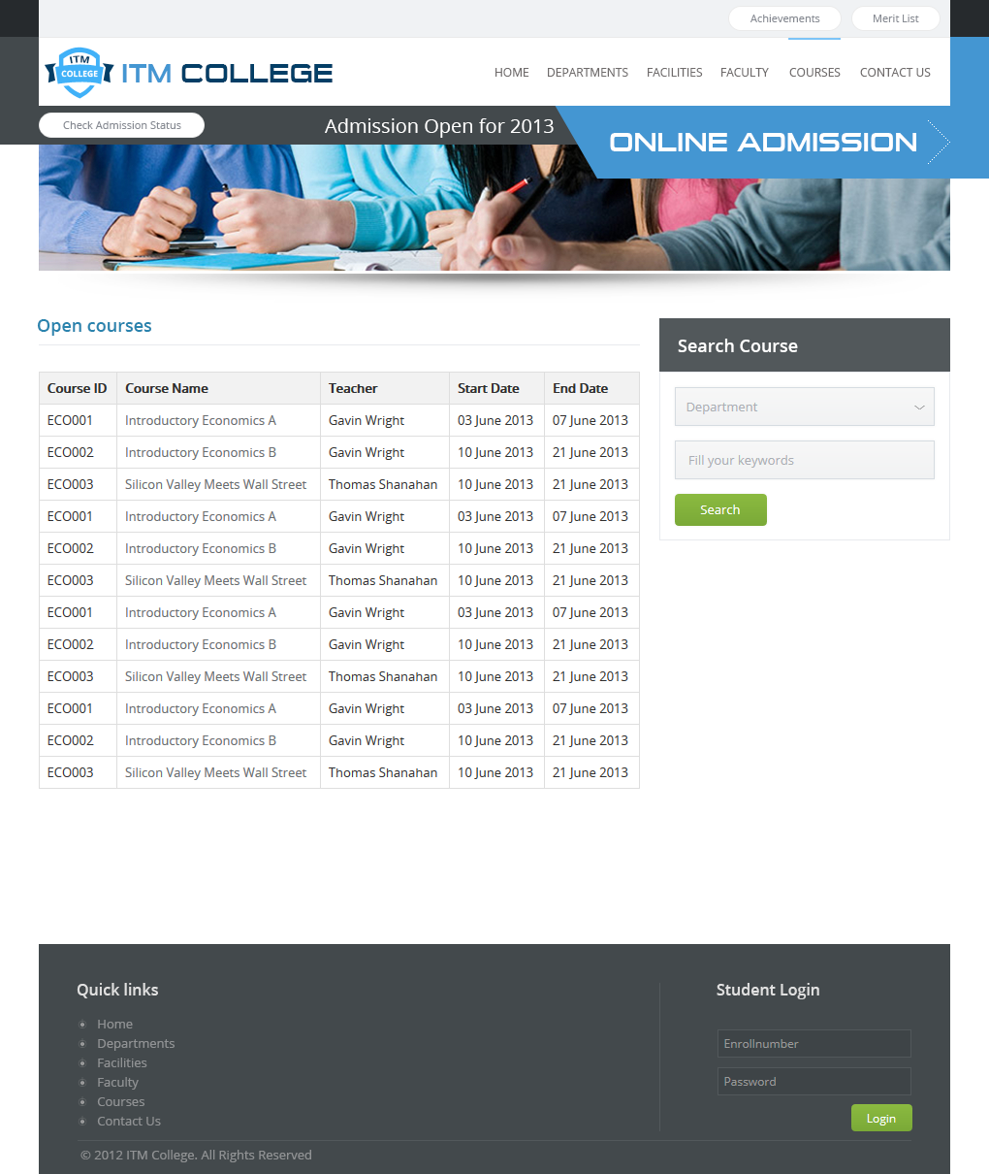

## Contact

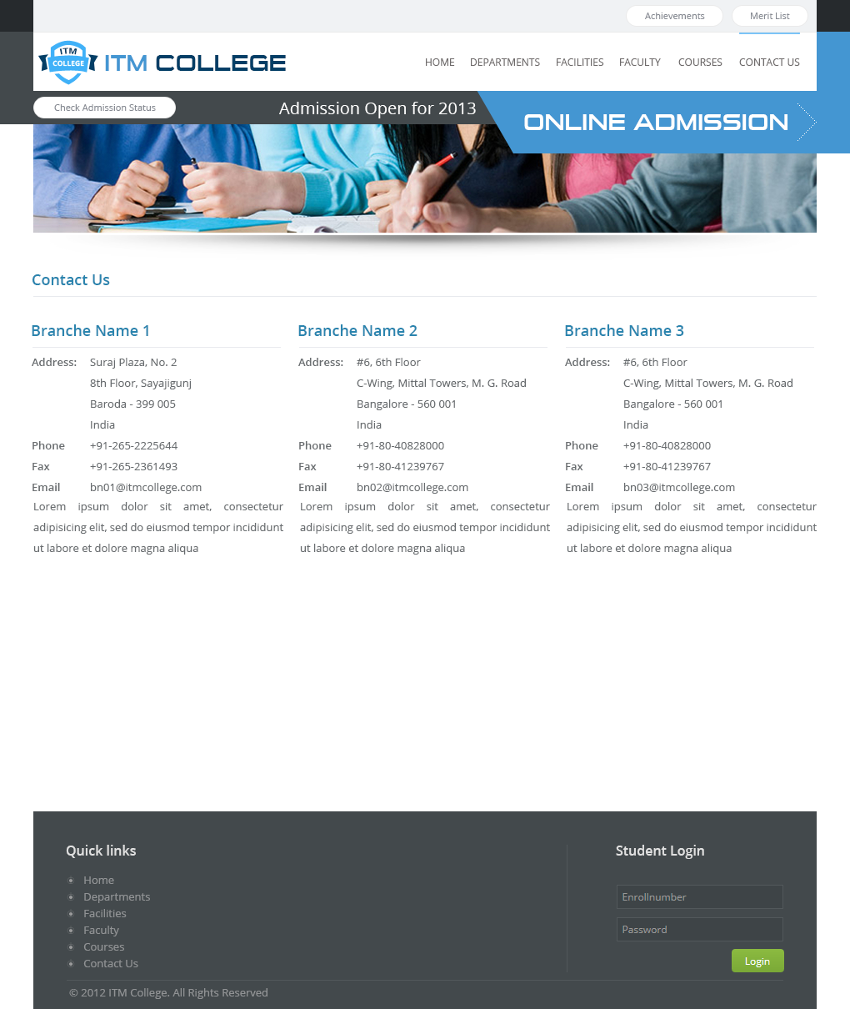

## Online Admission Form



|  |  |  |  |  |  |  |
| --- | --- | --- | --- | --- | --- | --- |
| **Online Admission** | | | | | | |
| **No.** | **Name** | **Type** | **Validation** | **Event** | **Description** | **Status** |
| 1 | txtName | Textbox | not null |  | Registered admission name | Enable |
| 2 | txtFatherName | Textbox | not null |  | Registered admission Father name | Enable |
| 3 | txtMothername | Textbox | not null |  | Registered admission mother name | Enable |
| 4 | txtBirthday | Textbox | not null |  | Registered admission birthday | Enable |
| 5 | radGender | Textbox | not null |  | Registered admission gender | Enable |
| 6 | txtResidentialAddress | Textbox | not null |  | Registered admission Residential address | Enable |
| 7 | txtPermanentAddress | Textbox | not null |  | Registered admission Permanent Address | Enable |
| 8 | txtSportDetail | Textbox |  |  | Registered admission Sport | Enable |
| 9 | txtUniversity | Textbox |  |  | Registered admission previous University | Enable |
| 10 | txtClass | Textbox |  |  | Registered admission previous class | Enable |
| 11 | txtEnrolNumber | Textbox |  |  | Registered admission previous Enrol Number | Enable |
| 12 | txtCenter | Textbox |  |  | Registered admission previous center | Enable |
| 13 | txtStream | Textbox |  |  | Registered admission previous stream | Enable |
| 14 | txtField | Textbox |  |  | Registered admission previous field | Enable |
| 15 | txtMarkSecured | Textbox |  |  | Registered admission previous mark secured | Enable |
| 16 | txtOutOf | Textbox |  |  | Registered admission previous Out of | Enable |
| 17 | txtClassObtained | Textbox |  |  | Registered admission previous Class obtained | Enable |
| 18 | ButtonSubmit | Button |  | Click | Process Online Admission | Enable |
| 19 | ButtonCancel | Button |  | Click | Return previous page | Enable |

## Check Admission Status



|  |  |  |  |  |  |  |
| --- | --- | --- | --- | --- | --- | --- |
| **Check Admission Status** | | | | | | |
| No. | Name | Type | Validation | Event | Description | Status |
| 1 | txtUniqueID | Textbox | not null |  | Unique ID provided for student after Registered Online Admission | Enable |
| 3 | ButtonSubmit | Button |  | Click | Process check Admission Status | Enable |
| 4 | ButtonCancel | Button |  | Click | Return to previous page | Enable |

## Student Registration



|  |  |  |  |  |  |  |
| --- | --- | --- | --- | --- | --- | --- |
| **Student Registration** | | | | | | |
| No. | Name | Type | Validation | Event | Description | Status |
| 1 | listDepartment | Dropdown List |  |  | Department list of College | Enable |
| 2 | linkRegister | Hyperlink |  | Click | Link to Register Selected Couse | Enable |

# GUI Design – Back-End

## Login Form



|  |  |  |  |  |  |  |
| --- | --- | --- | --- | --- | --- | --- |
| **Administrator & Staff Login** | | | | | | |
| No. | Name | Type | Validation | Event | Description | Status |
| 1 | txtUsername | Textbox | Not null |  | Username of Student | Enable |
| 2 | txtPassword | Textbox (Mode Password) | Not null |  | Password of Student | Enable |
| 3 | ButtonLogin | Button |  | Click | Process Login Request | Enable |
| 4 | ButtonCancel | Button |  | Click | Return to previous page | Enable |

## Administrator Dashboard

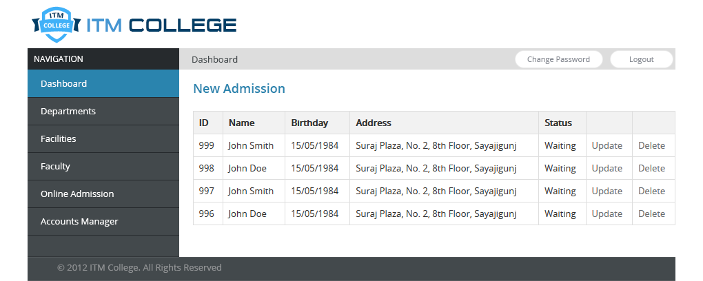

|  |  |  |  |  |  |  |
| --- | --- | --- | --- | --- | --- | --- |
| **Administrator Dashboard** | | | | | | |
| No. | Name | Type | Validation | Event | Description | Status |
| 1 | linkChangePassword | Hyperlink |  | Click | Link to Change Password page | Enable |
| 2 | linkLogout | Hyperlink |  | Click | Logout Administrator | Enable |
| 3 | linkUpdate | Hyperlink |  | Click | Link to Update Admission page | Enable |
| 4 | linkDelete | Hyperlink |  | Click | Link to Delete Admission page | Enable |

## Administrator – Departments

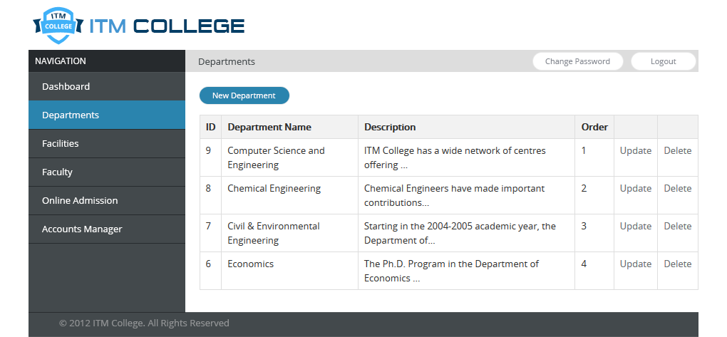

|  |  |  |  |  |  |  |
| --- | --- | --- | --- | --- | --- | --- |
| **Administrator Departments** | | | | | | |
| No. | Name | Type | Validation | Event | Description | Status |
| 1 | linkNewDepartment | Hyperlink |  | Click | Link to Create New Department page | Enable |
| 3 | linkUpdate | Hyperlink |  | Click | Link to Update Department page | Enable |
| 4 | linkDelete | Hyperlink |  | Click | Link to Delete Department page | Enable |

## Administrator – Departments – Create New / Edit

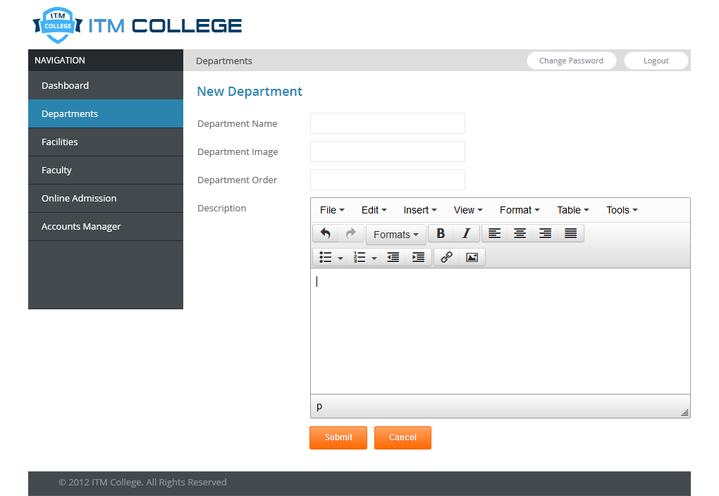

|  |  |  |  |  |  |  |
| --- | --- | --- | --- | --- | --- | --- |
| **Create / Edit Department** | | | | | | |
| **No.** | **Name** | **Type** | **Validation** | **Event** | **Description** | **Status** |
| 1 | txtDepartmentName | Text Box | Not Null  Length: 250 |  | Name of Department | Enable |
| 3 | txtDepartmentImage | Text Box | Length: 250 |  | Image of Department | Enable |
| 4 | txtOrder | Text Box |  |  | Display order of Department | Enable |
| 5 | txtDescription | Text Box |  |  | Description of Department | Enable |
| 6 | ButtonSubmit | Button |  | Click | Process Create/Edit | Enable |
| 7 | ButtonCancel | Button |  | Click | Return previous page | Enable |

## Administrator – Departments – Delete

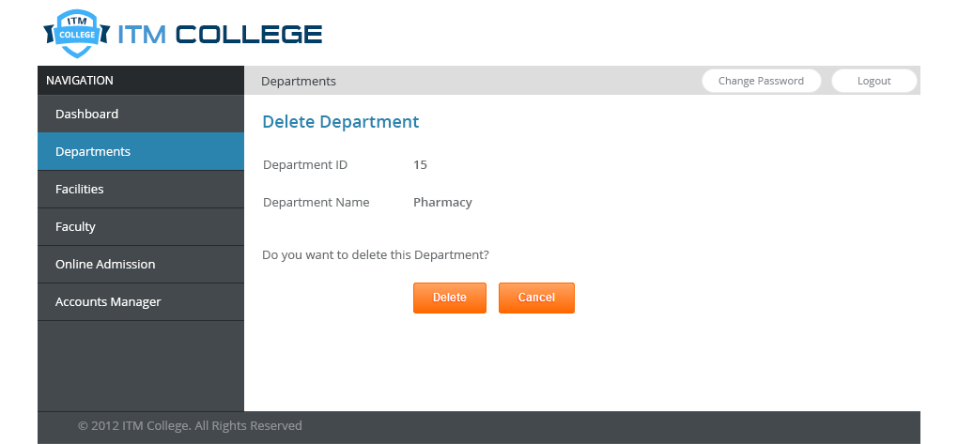

|  |  |  |  |  |  |  |
| --- | --- | --- | --- | --- | --- | --- |
| **Delete Department** | | | | | | |
| **No.** | **Name** | **Type** | **Validation** | **Event** | **Description** | **Status** |
| 1 | lblDepartmentID | Label |  |  | ID of Department | Enable |
| 3 | lblDepartmentName | Label |  |  | Name of Department | Enable |
| 6 | ButtonDelete | Button |  | Click | Process Delete Department | Enable |
| 7 | ButtonCancel | Button |  | Click | Return previous page | Enable |

## Administrator – Facilities

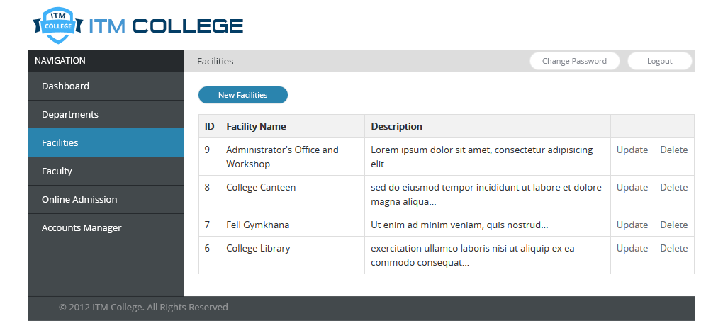

|  |  |  |  |  |  |  |
| --- | --- | --- | --- | --- | --- | --- |
| **Administrator Facilities** | | | | | | |
| No. | Name | Type | Validation | Event | Description | Status |
| 1 | linkNewFacilities | Hyperlink |  | Click | Link to Create New Facility page | Enable |
| 3 | linkUpdate | Hyperlink |  | Click | Link to Update Facility page | Enable |
| 4 | linkDelete | Hyperlink |  | Click | Link to Delete Facility page | Enable |

## Administrator – Facilities – Form Add/Edit

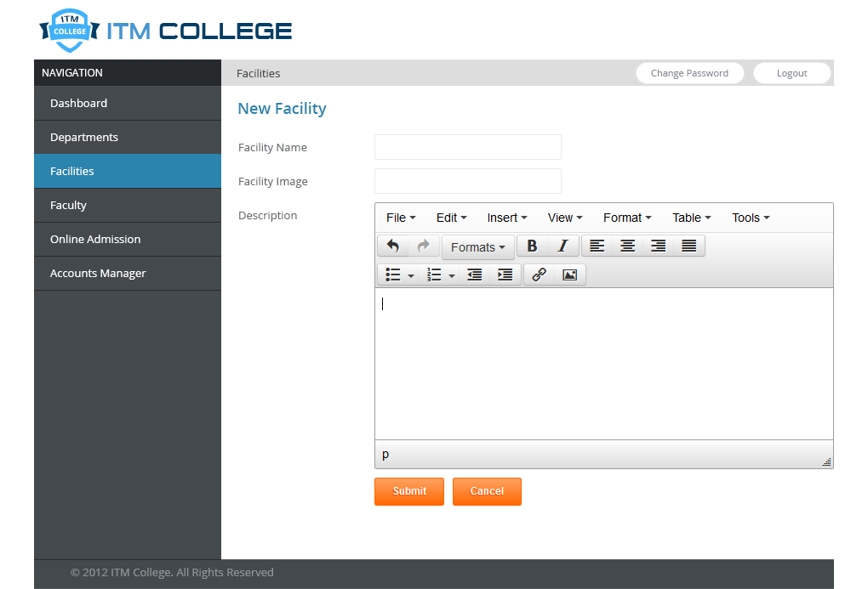

|  |  |  |  |  |  |  |
| --- | --- | --- | --- | --- | --- | --- |
| **Add / Edit Facility** | | | | | | |
| **No.** | **Name** | **Type** | **Validation** | **Event** | **Description** | **Status** |
| 1 | txtFacilityName | Text Box | Not Null  Length: 250 |  | Name of Facility | Enable |
| 2 | txtFacilityImage | Text Box | Length: 250 |  | Image of Facility | Enable |
| 3 | txtDescription | Text Box |  |  | Description of Facility | Enable |
| 4 | ButtonSubmit | Button |  | Click | Process Add/Edit Facility | Enable |
| 5 | ButtonCancel | Button |  | Click | Return previous page | Enable |

## Administrator – Facilities – Delete

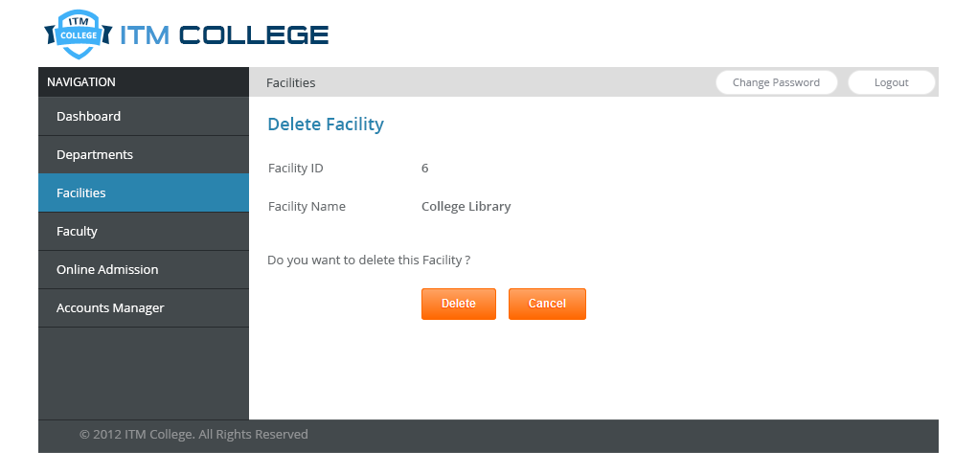

|  |  |  |  |  |  |  |
| --- | --- | --- | --- | --- | --- | --- |
| **Delete Facility** | | | | | | |
| **No.** | **Name** | **Type** | **Validation** | **Event** | **Description** | **Status** |
| 1 | lblFacilityID | Label |  |  | ID of Facility | Enable |
| 3 | lblFacilityName | Label |  |  | Name of Facility | Enable |
| 6 | ButtonDelete | Button |  | Click | Process Delete Facility | Enable |
| 7 | ButtonCancel | Button |  | Click | Return previous page | Enable |

## Administrator – Faculty

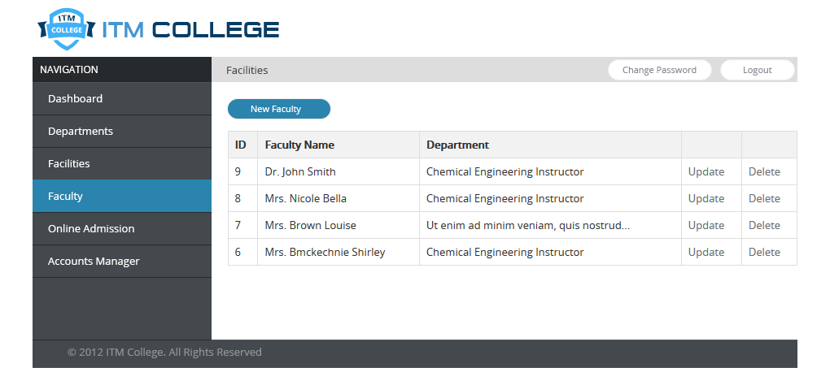

|  |  |  |  |  |  |  |
| --- | --- | --- | --- | --- | --- | --- |
| **Administrator Faculty** | | | | | | |
| No. | Name | Type | Validation | Event | Description | Status |
| 1 | linkNewFaculty | Hyperlink |  | Click | Link to Create New Faculty page | Enable |
| 3 | linkUpdate | Hyperlink |  | Click | Link to Update Faculty page | Enable |
| 4 | linkDelete | Hyperlink |  | Click | Link to Delete Faculty page | Enable |

## Administrator – Faculty – Add/Edit Form

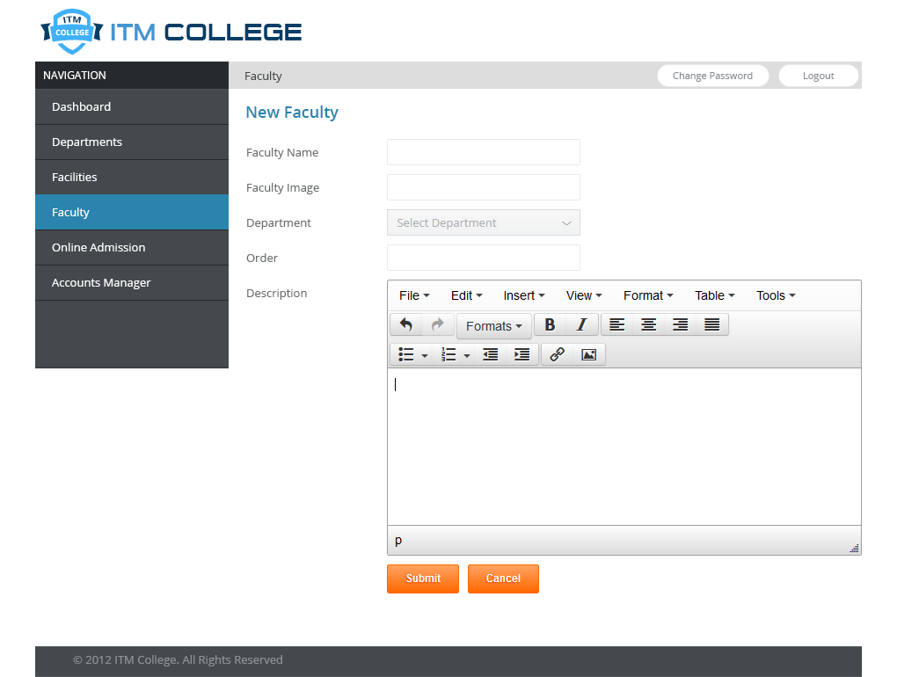

|  |  |  |  |  |  |  |
| --- | --- | --- | --- | --- | --- | --- |
| **Add / Edit Faculty** | | | | | | |
| **No.** | **Name** | **Type** | **Validation** | **Event** | **Description** | **Status** |
| 1 | txtFacultyName | Text Box | Not Null  Length: 250 |  | Name of Faculty | Enable |
| 2 | txtFacultyImage | Text Box | Length: 250 |  | Image of Faculty | Enable |
| 3 | txtDepartment | Dropdown List |  |  | Department of Faculty | Enable |
| 4 | txtOrder | Text Box |  |  | Display order of Faculty | Enable |
| 5 | txtDescription | Text Box |  |  | Description of Faculty | Enable |
| 6 | ButtonSubmit | Button |  | Click | Process Add/Edit Faculty | Enable |
| 7 | ButtonCancel | Button |  | Click | Return previous page | Enable |

## Administrator – Faculty – Delete

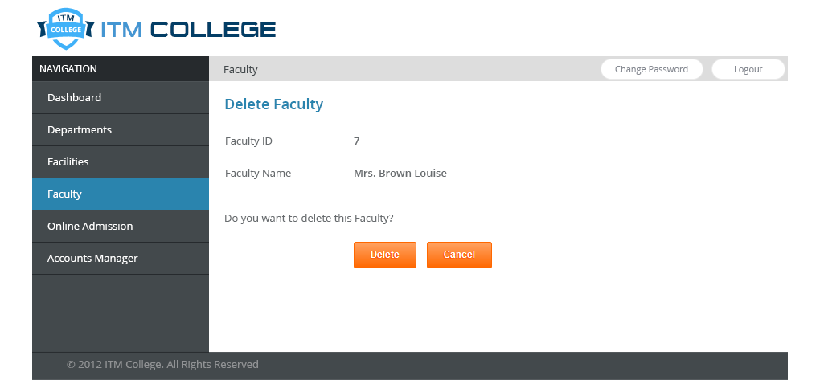

|  |  |  |  |  |  |  |
| --- | --- | --- | --- | --- | --- | --- |
| **Delete Faculty** | | | | | | |
| **No.** | **Name** | **Type** | **Validation** | **Event** | **Description** | **Status** |
| 1 | lblFacultyID | Label |  |  | ID of Faculty | Enable |
| 2 | lblFacultyName | Label |  |  | Name of Faculty | Enable |
| 3 | ButtonDelete | Button |  | Click | Process Delete Faculty | Enable |
| 4 | ButtonCancel | Button |  | Click | Return previous page | Enable |

## Administrator – Online Admission

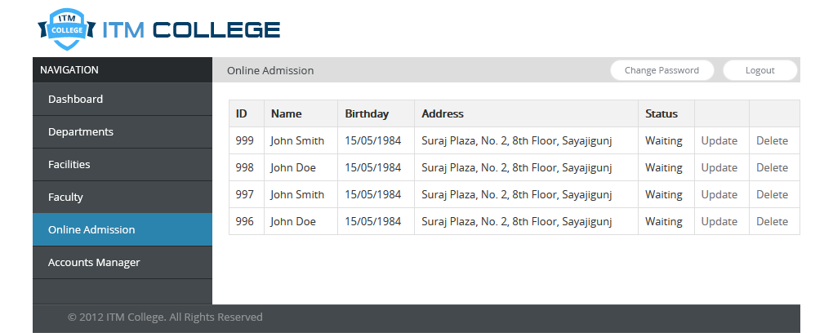

|  |  |  |  |  |  |  |
| --- | --- | --- | --- | --- | --- | --- |
| **Online Admission** | | | | | | |
| **No.** | **Name** | **Type** | **Validation** | **Event** | **Description** | **Status** |
| 1 | linkUpdate | Hyperlink |  |  | Link to Update Admission Page | Enable |
| 2 | linkDelete | Hyperlink |  | Click | Link to Delete Admission Page | Enable |

## Administrator – Online Admission – Update

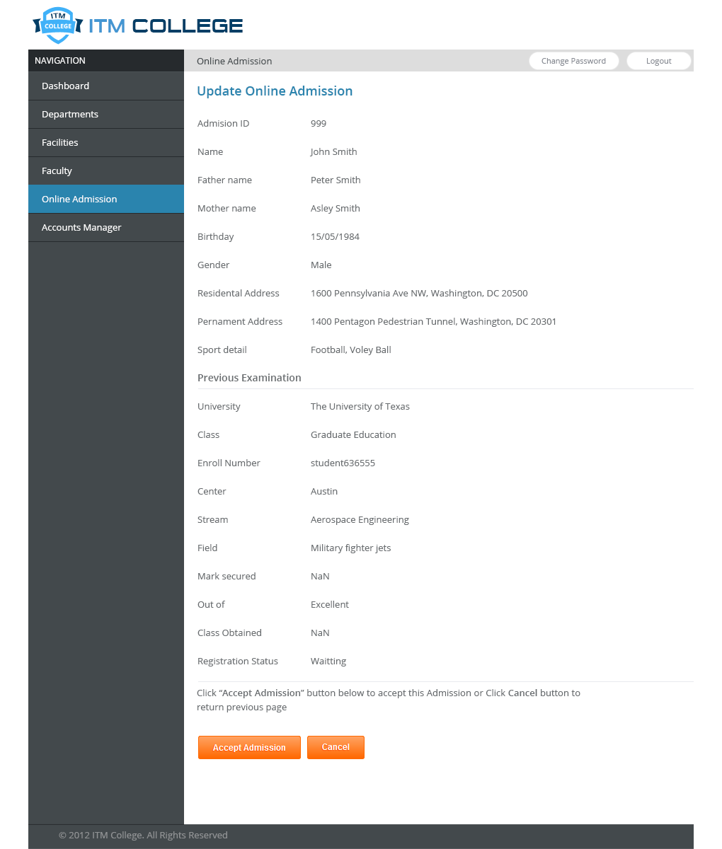

|  |  |  |  |  |  |  |
| --- | --- | --- | --- | --- | --- | --- |
| **Online Admission** | | | | | | |
| **No.** | **Name** | **Type** | **Validation** | **Event** | **Description** | **Status** |
| 1 | lblAdmissionID | Label |  |  | ID of Admission | Enable |
| 2 | lblName | Label |  |  | Registered admission name | Enable |
| 3 | lblFatherName | Label |  |  | Registered admission Father name | Enable |
| 4 | lblMotherName | Label |  |  | Registered admission mother name | Enable |
| 5 | lblBirthday | Label |  |  | Registered admission birthday | Enable |
| 6 | lblGender | Label |  |  | Registered admission gender | Enable |
| 7 | lblResidentialAddress | Label |  |  | Registered admission Residential address | Enable |
| 8 | lblPermanentAddress | Label |  |  | Registered admission Permanent Address | Enable |
| 9 | lblSportDetail | Label |  |  | Registered admission Sport | Enable |
| 10 | lblUniversity | Label |  |  | Registered admission previous University | Enable |
| 11 | lblClass | Label |  |  | Registered admission previous class | Enable |
| 12 | lblEnrolNumber | Label |  |  | Registered admission previous Enrol Number | Enable |
| 13 | lblCenter | Label |  |  | Registered admission previous center | Enable |
| 14 | lblStream | Label |  |  | Registered admission previous stream | Enable |
| 15 | lblField | Label |  |  | Registered admission previous field | Enable |
| 16 | lblMarkSecured | Label |  |  | Registered admission previous mark secured | Enable |
| 17 | lblOutOf | Label |  |  | Registered admission previous Out of | Enable |
| 18 | lblClassObtained | label |  |  | Registered admission previous Class obtained | Enable |
| 19 | lblRegistrationStatus | Label |  |  | Status of Admission | Enable |
| 20 | ButtonAccep Admission | Button |  | Click | Process Accept Admission | Enable |
| 21 | ButtonCancel | Button |  | Click | Return previous page | Enable |

## Administrator – Accounts

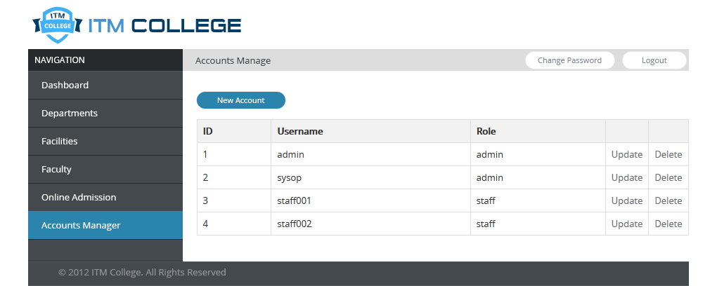

|  |  |  |  |  |  |  |
| --- | --- | --- | --- | --- | --- | --- |
| **Administrator – Accounts** | | | | | | |
| **No.** | **Name** | **Type** | **Validation** | **Event** | **Description** | **Status** |
| 1 | linkUpdate | Hyperlink |  | Click | Link to Update Admission Page | Enable |
| 2 | linkDelete | Hyperlink |  | Click | Link to Delete Admission Page | Enable |
| 3 | linkNewAccount | Hyperlink |  | Click | Link to New Account Page | Enable |

## Administrator – Account – Add/Edit Form

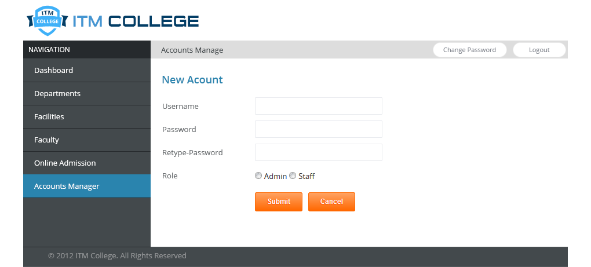

|  |  |  |  |  |  |  |
| --- | --- | --- | --- | --- | --- | --- |
| **Administrator – Accounts – Add/Edit Form** | | | | | | |
| **No.** | **Name** | **Type** | **Validation** | **Event** | **Description** | **Status** |
| 1 | txtUsername | Textbox | not null |  | Username of new account | Enable |
| 2 | txtPassword | Textbox  (Password) | not null |  | Password of new account | Enable |
| 3 | txtRetype-Password | Textbox  (Password) | not null  equal Password |  | Confirm password of new account | Enable |
| 4 | radAdmin | Radio | checked | click | Role of new account | Enable |
| 5 | radStaff | Radio | checked | click | Role of new account | Enable |
| 6 | ButtonSubmit | Button |  | Click | Process create/edit account | Enable |
| 7 | ButtonCancel | Button |  | Click | Return previous page | Enable |

## Administrator – Account - Delete

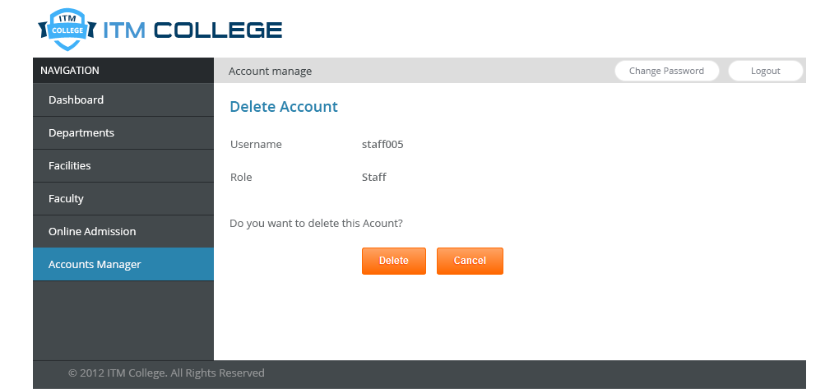

|  |  |  |  |  |  |  |
| --- | --- | --- | --- | --- | --- | --- |
| **Delete Account** | | | | | | |
| **No.** | **Name** | **Type** | **Validation** | **Event** | **Description** | **Status** |
| 1 | lblUsername | Label |  |  | Username of Account | Enable |
| 2 | lblRole | Label |  |  | Role of Account | Enable |
| 3 | ButtonDelete | Button |  | Click | Process Delete Account | Enable |
| 4 | ButtonCancel | Button |  | Click | Return previous page | Enable |

## Administrator – Branches

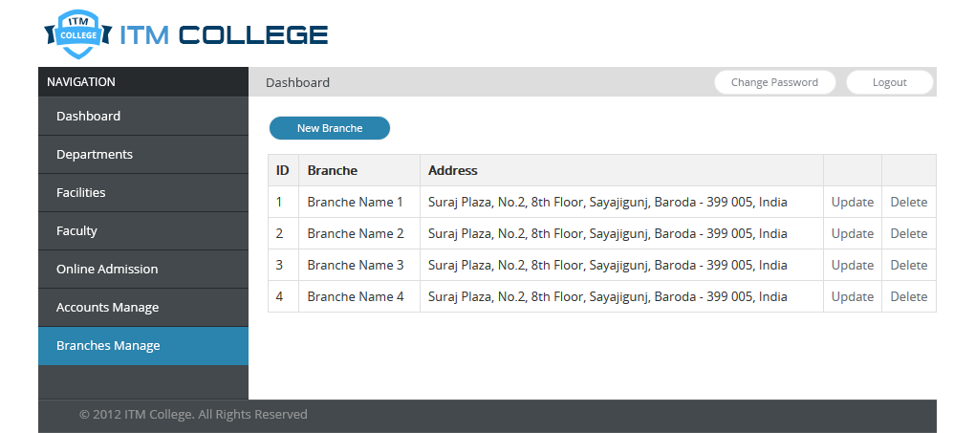

|  |  |  |  |  |  |  |
| --- | --- | --- | --- | --- | --- | --- |
| **Administrator – Branches** | | | | | | |
| **No.** | **Name** | **Type** | **Validation** | **Event** | **Description** | **Status** |
| 1 | linkUpdate | Hyperlink |  | Click | Link to Update Branches Page | Enable |
| 2 | linkDelete | Hyperlink |  | Click | Link to Delete Branches Page | Enable |
| 3 | linkNewBranches | Hyperlink |  | Click | Link to New Branches Page | Enable |

## Administrator – Branches – Add/Edit

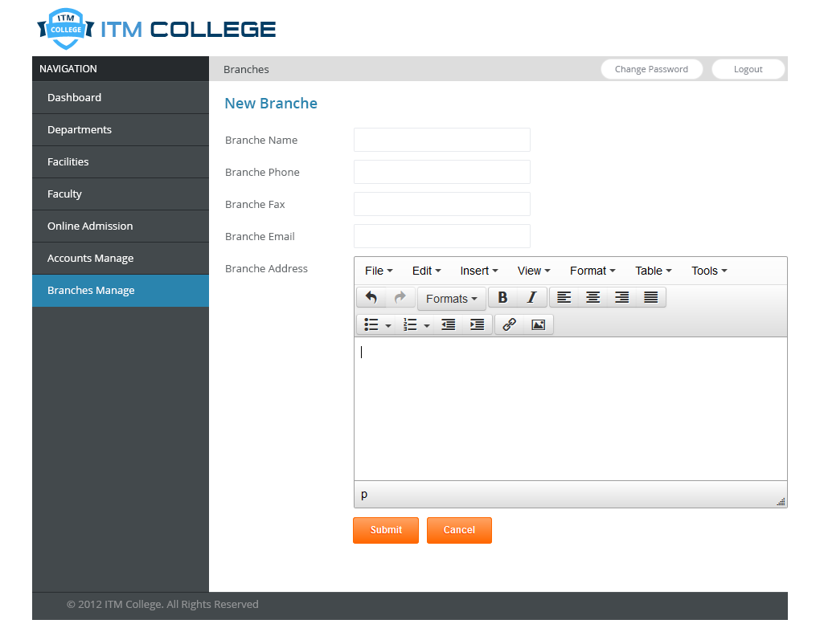

|  |  |  |  |  |  |  |
| --- | --- | --- | --- | --- | --- | --- |
| **Add / Edit Branches** | | | | | | |
| **No.** | **Name** | **Type** | **Validation** | **Event** | **Description** | **Status** |
| 1 | txtBranchesName | Text Box | Not Null  Length: 250 |  | Name of Branches | Enable |
| 3 | txtBranchesPhone | Text Box | Length: 250 |  | Phone of Branches | Enable |
| 4 | txtBranchesFax | Text Box | Length: 250 |  | Display order of Branches | Enable |
| 5 | txtBranchesEmail | Text Box | Length: 250 |  | Email of Branches | Enable |
| 5 | txtDescription | Text Box |  |  | Description of Branches | Enable |
| 6 | ButtonSubmit | Button |  | Click | Process Add/Edit | Enable |
| 7 | ButtonCancel | Button |  | Click | Return previous page | Enable |

## Administrator – Branches – Delete

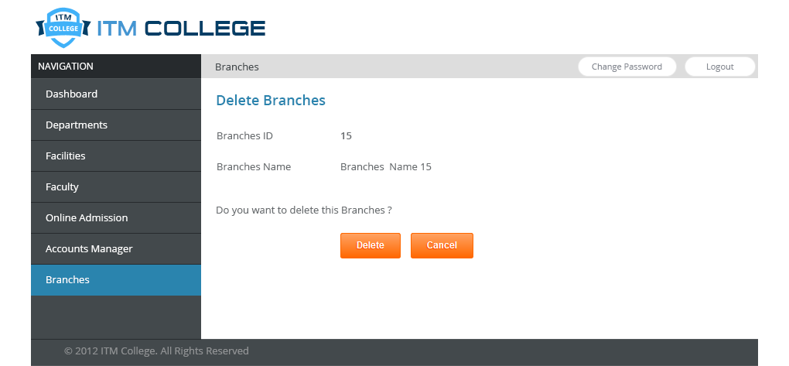

|  |  |  |  |  |  |  |
| --- | --- | --- | --- | --- | --- | --- |
| **Delete Branches** | | | | | | |
| **No.** | **Name** | **Type** | **Validation** | **Event** | **Description** | **Status** |
| 1 | lblBranchesID | Label |  |  | ID of Branches | Enable |
| 2 | lblBranchesName | Label |  |  | Name of Branches | Enable |
| 3 | ButtonDelete | Button |  | Click | Process Delete Branches | Enable |
| 4 | ButtonCancel | Button |  | Click | Return previous page | Enable |

## Change Password

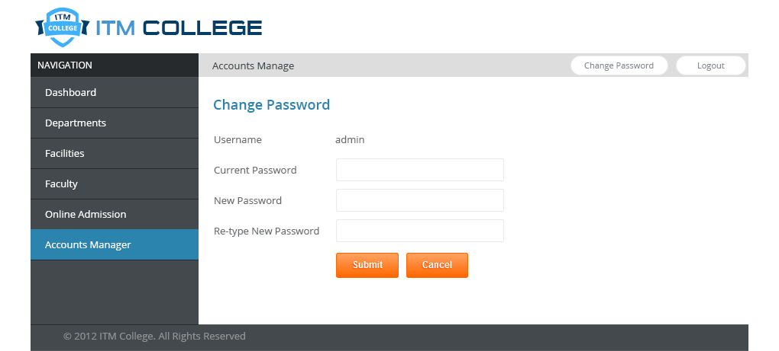

|  |  |  |  |  |  |  |
| --- | --- | --- | --- | --- | --- | --- |
| **Change Password** | | | | | | |
| **No.** | **Name** | **Type** | **Validation** | **Event** | **Description** | **Status** |
| 1 | lblUsername | Label |  |  | Username of Account | Enable |
| 2 | txtCurrentPassword | Textbox  (Password) | not null |  | Current password of Account | Enable |
| 3 | txctNewPassword | Textbox  (Password) | not null |  | New password | Enable |
| 4 | txtRe-typeNewPassword | Textbox  (Password) | not null  equal New Password |  | Re-type new password | Enable |
| 5 | ButtonDelete | Button |  | Click | Process Change Password | Enable |
| 6 | ButtonCancel | Button |  | Click | Return previous page | Enable |

## Staff Dashboard

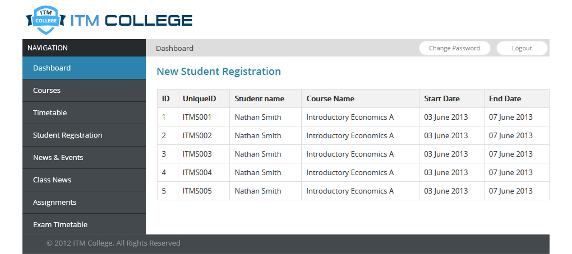

## Staff – Courses

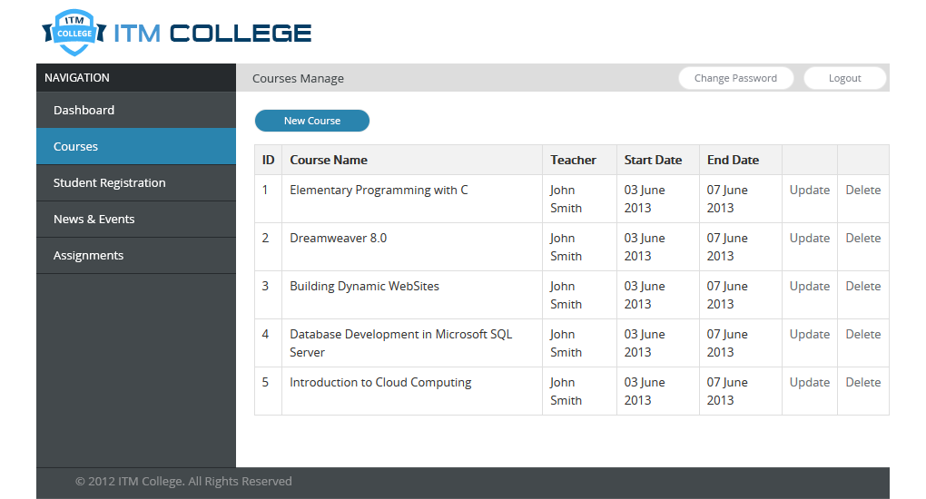

|  |  |  |  |  |  |  |
| --- | --- | --- | --- | --- | --- | --- |
| **Courses Manage** | | | | | | |
| **No.** | **Name** | **Type** | **Validation** | **Event** | **Description** | **Status** |
| 1 | linkNewCourse | Hyperlink |  | Click | Link to Create Course page | Enable |
| 2 | linkUpdate | Hyperlink |  | Click | Link to Update Course page | Enable |
| 3 | linkDelete | Hyperlink |  | Click | Link to Update Course page | Enable |

## Staff – Course – Add/Edit

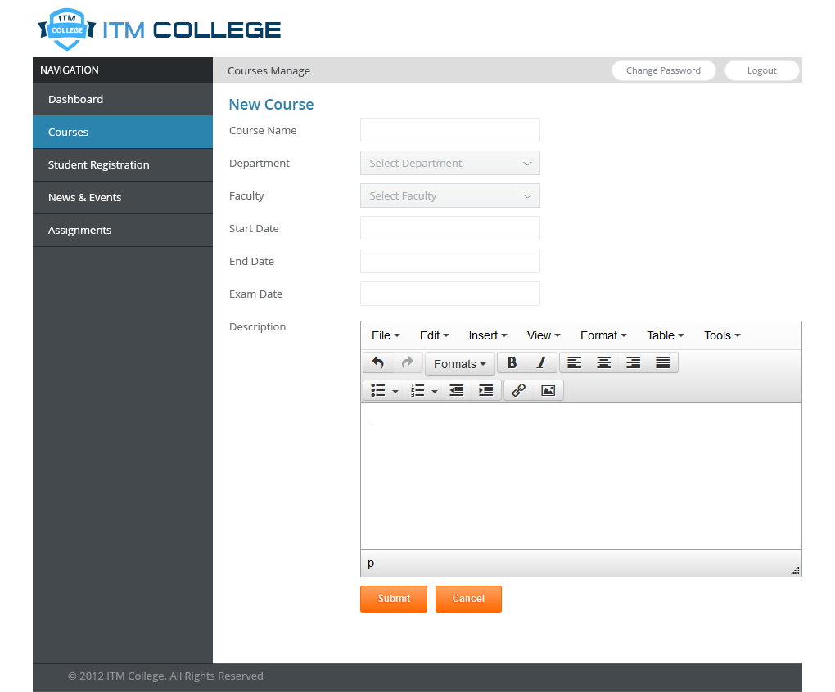

|  |  |  |  |  |  |  |
| --- | --- | --- | --- | --- | --- | --- |
| **Add/Edit Course** | | | | | | |
| **No.** | **Name** | **Type** | **Validation** | **Event** | **Description** | **Status** |
| 1 | txtCourseName | Textbox | not null |  | Name of Course | Enable |
| 2 | txtDepartment | Dropdown List | Selected |  | Department of Course | Enable |
| 3 | txtFaculty | Dropdown List | Selected |  | Faculty of Course | Enable |
| 4 | txtStartDate | Textbox |  |  | Start date of Course | Enable |
| 5 | txtEndDate | Textbox |  |  | End date of Course | Enable |
| 6 | txtExamDate | Textbox |  |  | Exam date of Course | Enable |
| 7 | txtDescription | Textbox  (Multiline) |  |  | Description of Course | Enable |
| 8 | ButtonSubmit | Button |  | Click | Process add/edit course | Enable |
| 9 | ButtonCancel | Button |  | Click | Return previous page | Enable |

## Staff – Student

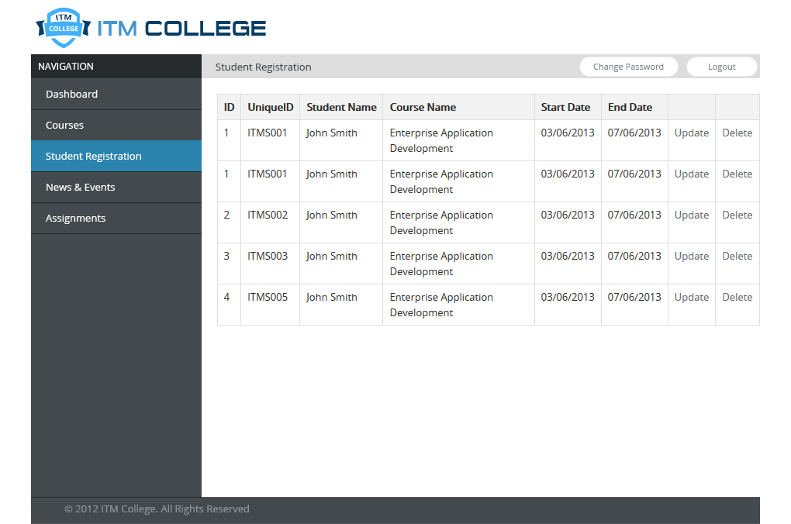

## Staff – College Content

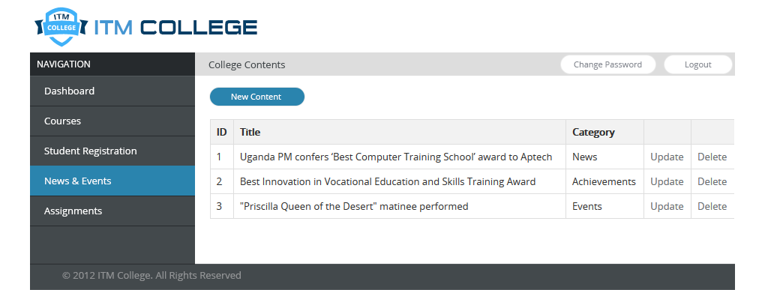

|  |  |  |  |  |  |  |
| --- | --- | --- | --- | --- | --- | --- |
| **College Contents** | | | | | | |
| **No.** | **Name** | **Type** | **Validation** | **Event** | **Description** | **Status** |
| 1 | linkNewContent | Hyperlink |  | Click | Link to Create Content page | Enable |
| 2 | linkUpdate | Hyperlink |  | Click | Link to Update Content page | Enable |
| 3 | linkDelete | Hyperlink |  | Click | Link to Update Content page | Enable |

## Staff – College Content – Form

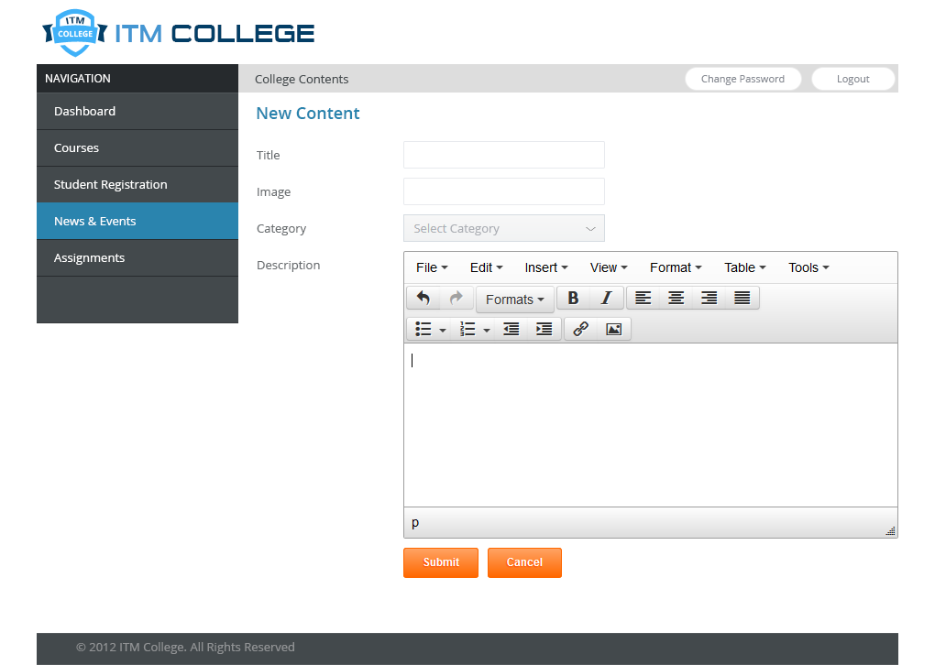

|  |  |  |  |  |  |  |
| --- | --- | --- | --- | --- | --- | --- |
| **Add/Edit College Contents** | | | | | | |
| **No.** | **Name** | **Type** | **Validation** | **Event** | **Description** | **Status** |
| 1 | txtTitle | Textbox |  |  | Title of Content | Enable |
| 2 | txtImage | Textbox |  |  | Image of Content | Enable |
| 3 | listCategory | Dropdown List |  |  | Select Content category | Enable |
| 4 | txtText | Textbox |  |  | Text of Content | Enable |
| 5 | ButtonSubmit | Button |  |  | Process add/Edit Content | Enable |
| 6 | ButtonCancel | Button |  |  | Return previous page | Enable |

## Staff – Assignment

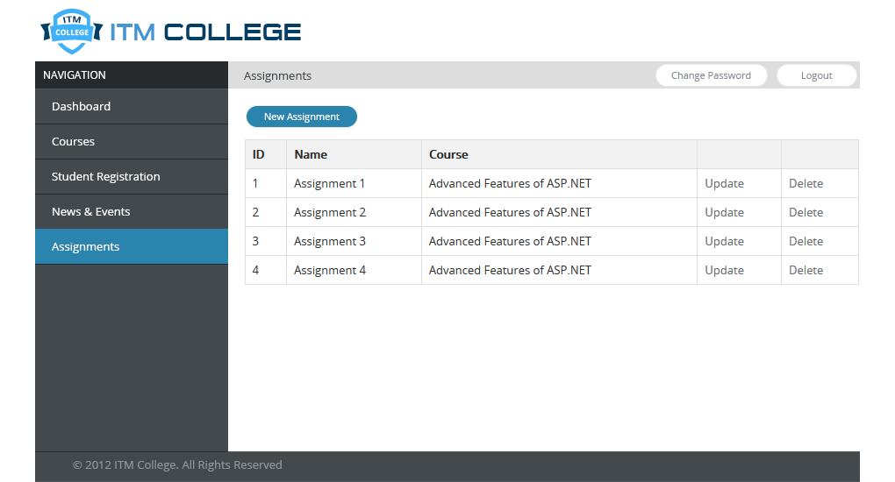

|  |  |  |  |  |  |  |
| --- | --- | --- | --- | --- | --- | --- |
| **Staff - Assignments** | | | | | | |
| **No.** | **Name** | **Type** | **Validation** | **Event** | **Description** | **Status** |
| 1 | linkNewAssignment | Hyperlink |  | Click | Link to Create Assignment page | Enable |
| 2 | linkUpdate | Hyperlink |  | Click | Link to Update Content page | Enable |
| 3 | linkDelete | Hyperlink |  | Click | Link to Update Content page | Enable |

## Staff – Assignments – Add/Edit

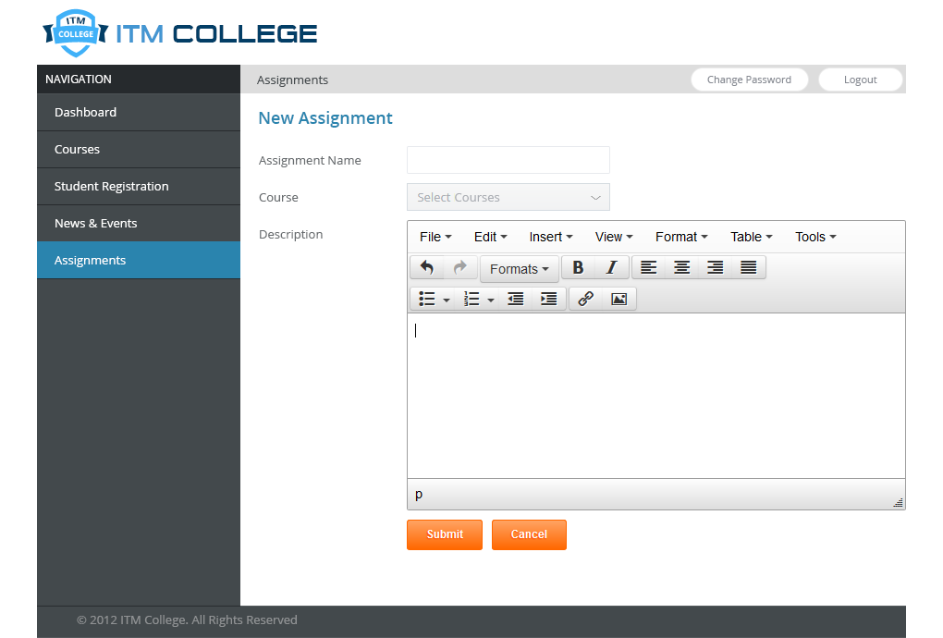

|  |  |  |  |  |  |  |
| --- | --- | --- | --- | --- | --- | --- |
| **Add/Edit Assignment** | | | | | | |
| **No.** | **Name** | **Type** | **Validation** | **Event** | **Description** | **Status** |
| 1 | txtAssignmentName | Textbox |  |  | Name of Assignment | Enable |
| 2 | listCourse | Dropdown List |  |  | Select Assignment’s Course | Enable |
| 3 | txtDescription | Textbox |  |  | Description of Assignment | Enable |
| 4 | ButtonSubmit | Button |  |  | Process add/Edit Assignment | Enable |
| 5 | ButtonCancel | Button |  |  | Return previous page | Enable |

# Sitemap

## Front-End Sitemap



## Back-End Sitemap



# Task sheet review 3

|  |  |  |  |  |  |
| --- | --- | --- | --- | --- | --- |
| Project Ref. No: 2 | Project Title:  ITM College Management | Date of Preparation of Activity Plan | | | |
| No. | Task | Actual Start Date | Actual Days | Team Member Name | Status |
| 01 | Database Relationship Diagram | May 04, 2013 | 10 | Le Ngoc Nhut  Tran Dung Tri  Tran Van Hai | Completed |
| 02 | Database Structure | Le Ngoc Nhut  Tran Dung Tri  Tran Van Hai | Completed |
| 03 | Database Constraints | Le Ngoc Nhut  Tran Dung Tri  Tran Van Hai | Completed |
| 04 | GUI Designs | Nguyen Vu Hung | Completed |

|  |  |  |
| --- | --- | --- |
|  | Prepare By: Group | Approved By: Faculty |
| Date: May 14, 2013 | Team Leader  Nguyen Vu Hung | Tran Phuoc Sinh |